JRE 1.8 installation guide



Double click on above file for installation of JRE 1.8

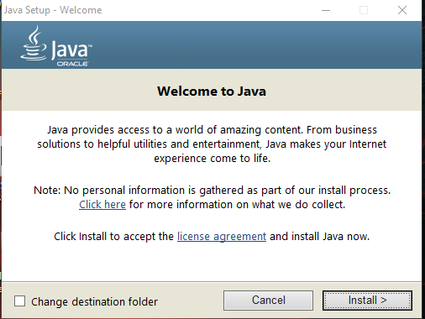

Click Install

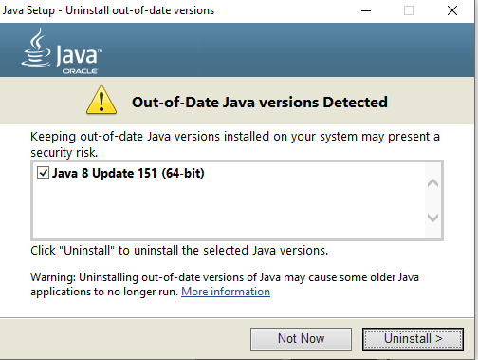

Click Uninstall for uninstall JRE 64 bit

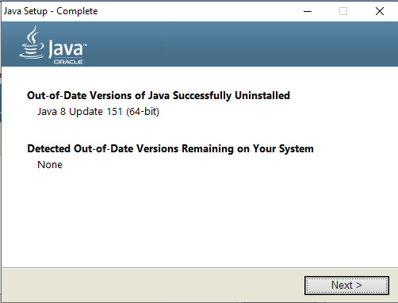

Click Next for installation of JRE 32 bit

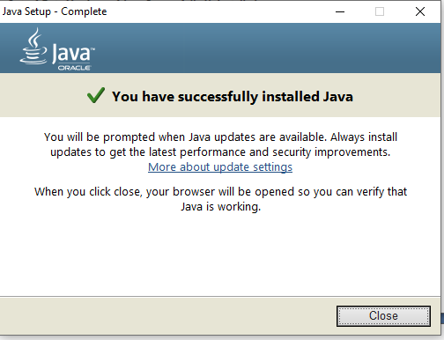

Click Close for Completion of JRE 1.8 installation